Student Resource Hub
Purpose: To provide students with easy access to academic materials, study tips and educational resources in one place.
Goal:
- Help students improve their academic performance
- Provide organized study materials
- Make learning resources easily accessible online

Target Audience
Age:15-25 years
Users: High school students and college students
Technical skills: Basic to intermediate
Needs:
- Notes and summaries
- Study tips
- Past papers
Type of website
Educational website
Information Design and Taxonomy
The information architecture of the student Resources Hub website is designed to ensure that users can easily find and navigate through academic resources. The content is logically organized into categories based on student’s needs, allowing for a simple and intuitive browsing experience.

Site map

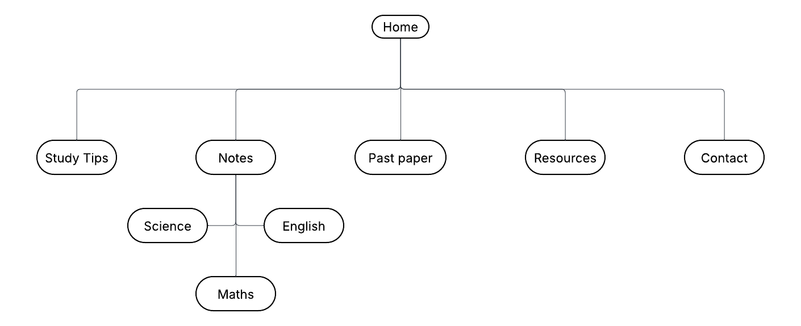
Main Navigation Paths:
1.Home ‘n Study Tips
2.Home ‘n Notes ‘n Mathematics
3.Home ‘n Notes ‘n Science
4.Home ‘n Notes ‘n English
5.Home ‘n Past paper
6.Home ‘n Resources
7.Home ‘n Contact

Main Categories:
- study Tips
- Time management
- Exam preparation
- Notes taking strategies
- Notes
- Mathematics
- Science
- English
- Past papers
- Previous exam papers
- Practice question
- Resources
- Educational website
- Online tools
- Learning videos
- Contact
- Email/contact form
- Feedback section

